Camera follow object:

Required setups:

1.Create an object around which the camera will rotate. (Target Object)

(Cube is created in order to follow the sphere, use fixed joint to attach the cube to sphere)

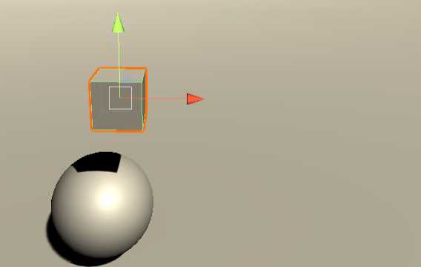

2.Turn off the mesh renderer in order to make it invisible.

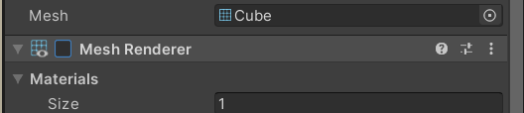

3.Attach the script to the camera.

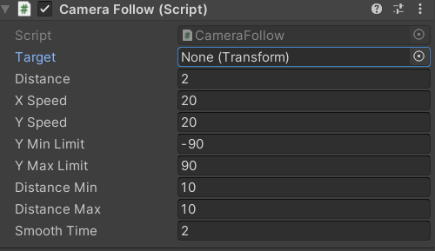

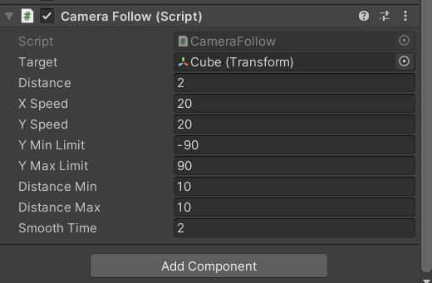
4.Attach the cube to the target object in the inspector section of the camera follow script.

5. Done ).

